**CAESR Training Session** W. Myers, Oct. 2021

Preliminary, have read CAESR User Form Document

**Morning ~ 10 am to 12 pm**

Explanation of webpage and online resources

Start, Run, \\chem.ox.ac.uk\SRF\ESR *1*… BrukerManuals\ *2*… NewUser_IntrosAndFAQ\

Spectrometer booking: CW by user; Pulsed in booking meeting

General Comments on doing research in ESR (*in CAESR*) … page 2

ESR Research Responsibility statement … page 3

Tour of

F19: clockwise loop of lab, file cabinet drawers, cryostats, resonators, standard samples

F11: lab layout, resonators, special start-up guide, LASER interlock, sign-off

F12: lab layout, magnetic field hazards, resonators, LASER interlock

F13: wet lab resources, Timmel Group resources, clean-up after yourself, COSHH

Services to Facility: helium dewar return manifold, light well lines, chiller locations (control repeaters)

F12 – E680 training

How to

Set up cryogenic flow conditions {liquid N2, liquid He}

Turn on the spectrometer {N2 gas, water, power supply, console, mw bridge, software}

Changing samples in Standby

Usage Pause for > 2 hr in your experiments, {TWT off, Magnet power supply off, microwave source in Standby, cryogen low-flow?}

Turn the spectrometer off {software, mw bridge, console, power supply, water, N2 gas}

Take-down cryogenic flow conditions

*StartHere_NewUser folder*

Instrumentation, layout of instruments, bridge schematic … page 5-7

GUNN source; ELDOR source;

CW path; LCW; Pulsed EPR path {SPFU; MPFU}

CW-EPR & Pulsed EPR of LiPc … page 8-9

Bruker pulse course 2007, BDPA at X-band and Q-band … page 10

**Afternoon ~ 2:30 pm to 5 pm**

Transient ESR – Zn(II)TPP *skipped, discussion only* … page 11

Double Electron-Electron Resonance *, discussion only* … page 12

Bruker Pulsed EPR Course 2007 – DEER std. hands-on exercises … page 12

**General Comments for Research in ESR**:

You should gain familiarity with relevant parts of the Bruker and Oxford Instrument manuals for each spectrometer you use and for transfer lines (LLT600), instrumentation temperature controllers (ITC-503, Mercury, VT-1000) and cryostats (CF-935, ESR-900).

Don’t adjust hardware settings or reconfigure console wiring connections without getting help the first few times. Don’t change cryostats unless trained by CAESR staff.

If you are unsure of doing something new on the spectrometer software settings, e.g. new PulseSPEL, ProDel, or detection methods, please get help to check that your setup is safe.

1. CW-EPR: Quantification of spin concentration, speciation, g-matrix and large hyperfine values, rapid tumbling room temperature ESR for isotropic values of slowly relaxing spins. Rotational correlation times.

2. Pulse-EPR: Resolve and characterize small anisotropic interactions, e.g. hyperfine, nuclear quadrupole, electron-electron dipole. Measure electron and nuclear relaxation times directly (more easily than in CW-EPR). Exchange correlation spectroscopy.

|  |  |
| --- | --- |
| **+** | **−** |
| Read current and past literature to write a research proposal for publishable results and make a realistic plan of samples, experiments, and people for your available appointment time.  Plan pulsed EPR experiments well in advance of your reservation.  . liquid helium order in place five days before  . samples prepared and stored as stable (77 K?)  . CW-EPR characterization completed, if useful  . outline of experiments and what information you want to obtain  . do simulations & DFT that will help guide parameter value settings in EPR experiments  . know the level of signal-to-noise required for each measurement and so don’t waste time  During measurements: make plots of your data as soon as possible and render preliminary analysis. Good plotting code will get data to near-publication quality figures with little effort. Start on simulations and report if possible. Make notes of analysis ideas.  Keep project participants well-informed, share the results within a few days in a written report with discussion points and possible future work. Explain remaining analysis and questions (it’s okay), then follow-up in meetings or on phone.  Ask for help if needed.  Carefully monitor personal health over multi-day runs. | Don’t try to order helium until the day before you start.  Assume your collaborators know everything about making a good ESR sample (what you need) and then email them a short list of sample requirements after the measurements fail.  Don’t start contacting your collaborator about your samples until they have no choice but devote 100% of their time, including evenings and weekends to make certain your samples are good before or during your measurement time.  Only use EPR to characterize samples.  Talk individually to many people with EPR-expertise who are not on your project about your results and polish the aggregate comments and analysis as your own, for your own exclusive meetings.  Collect many EPR data sets and put-off looking at them for months to years (perhaps not until you hear that someone is about to scoop you or just has).  Blame the spectrometer, supervisor, or someone else if experiments or analysis don’t work. Talk badly about them to other people.  Be hyper-independent -- do not ask for help or discuss results with anyone for weeks, months, or years, developing systematic bad habits that end in erroneous data acquisitions, analysis, and publications. |

ESR Research Responsibilities

As a researcher in CAESR, the measurements you perform, the analysis and reporting in publications and presentations reflect directly on the reputation of yourself, your supervisor(s), the Centre for Advanced ESR, the Department of Chemistry or your Department, and the University of Oxford as a whole. Therefore, maintenance of a high standard of research quality is essential as a singular merit and as the aim of REF2020. You are encouraged to learn ESR methods, become capable spectrometer users and ultimately, good ESR spectroscopists; however, please seek *free* consultation in the following, as needed:

Elements of ESR research quality:

1. CW-EPR characterization: non-saturating microwave power, slow-passage field sweep rate --in the limit of no effect on signal shape or field position shift, lower the temperature to the limit of narrow linewidths. Prepare sample concentrations in the limit of narrow linewidths. Choose solvents or solvent combinations that yield a glass (disordered dipoles) when frozen. Choose solvents and sample concentrations that avoid sample aggregation and precipitation in thefreezing process. Use a smoothing filter (analog and/or digital) of less than the linewidth. Sweep of the entire ESR signal in a spectrum that includes some baseline beyond the EPR signal, within reason for mostly Lorentzian lineshapes. Separate narrow sweeps over regions with high-detail and/or a change in receiver gain for separate sweeps on large variations of signal intensities. Prepare and measure control samples and check the resonator background under the acquisition conditions of the main sample.

Spectral subtraction is very useful for discriminating between species, especially in the case of different power saturation dependencies, i.e. relaxation, but extra caution must be applied to avoid over-interpretation and generation of spurious features and signals.

1. A quantitative determination of the number of spins in a sample, the number of molecules intended to have spin, as expected, and the number that do not; know the implications of spin concentration.
2. Discussion of literature for prior EPR measurements of related molecules and theoretical concerns.
3. Accurate EPR simulations and reporting of complete set(s) of simulation parameter values.
4. Correct determination of field-offset between Hall probe and sample, for g-value calculations.
5. Correct mapping of tensor orientations on the molecular frame, *when detail level is appropriate*.
6. Report in experimental section, results section, figures and figure legends with sufficient detail that experiments may be accurately reproduced by other people, elsewhere.
7. ESR figures: Give sufficient figure quality and axes labels that data may be subsequently digitized for comparison in experiment reproduction efforts and simulations. The field values (Magnetic Induction or Magnetic Flux Density) should be in SI units of milliTesla (mT) or Tesla; CGS units, Gauss, kG, remain *okay*. Spectrum regions of fine detail and/or very low relative intensity should be expanded in zoom insets or in supplementary information. These may be separate data acquisitions. Crop excessive baseline to show a bit of baseline, but mostly ESR signal with clear features.
8. Figure legends may include sample concentration, sample solvent, microwave frequency to 100s of kilohertz place, e.g. 9.4136 GHz --depending on source stability, sample temperature, microwave power, sweep rate, time constant (if analog smoothing) and conversion time. Some of this information may rather be included in the Methods section.

You should include somewhere in your paper a line similar to “EPR measurements were performed in the Centre for Advanced ESR (CAESR) located in the Department of Chemistry of the University of Oxford.” And in the acknowledgement, “CAESR is supported by UK EPSRC (EP/L011972/1).”

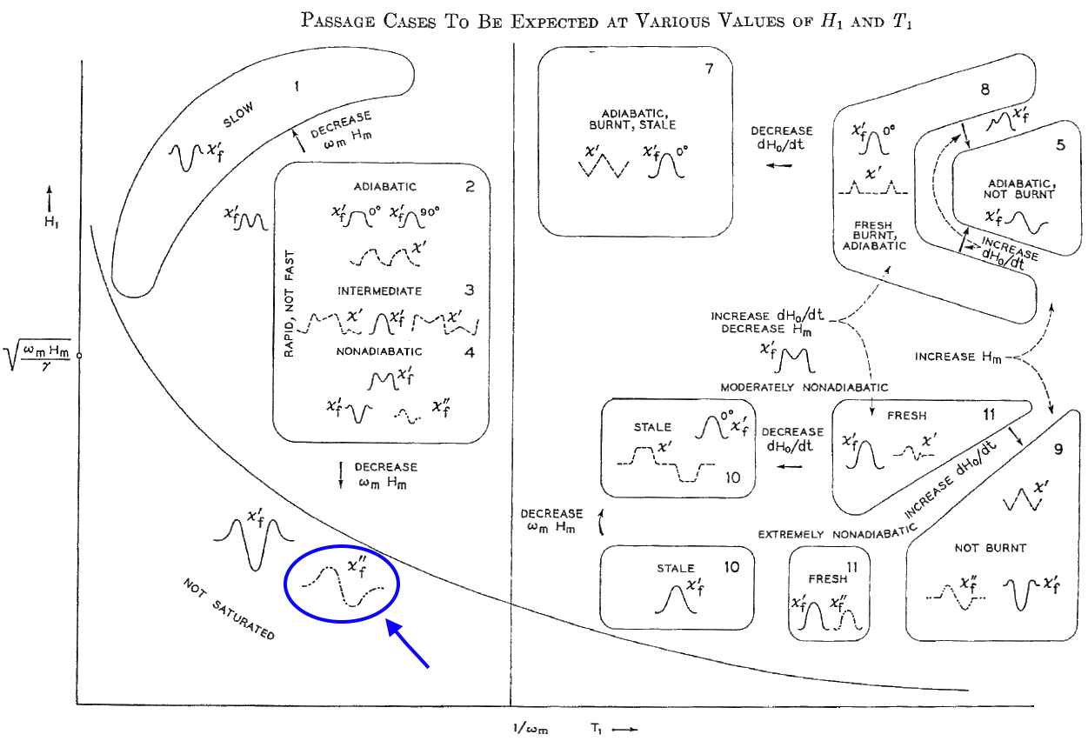

CW-EPR responses, according to M. Weger, Bell Sys. Tech. J., 1960

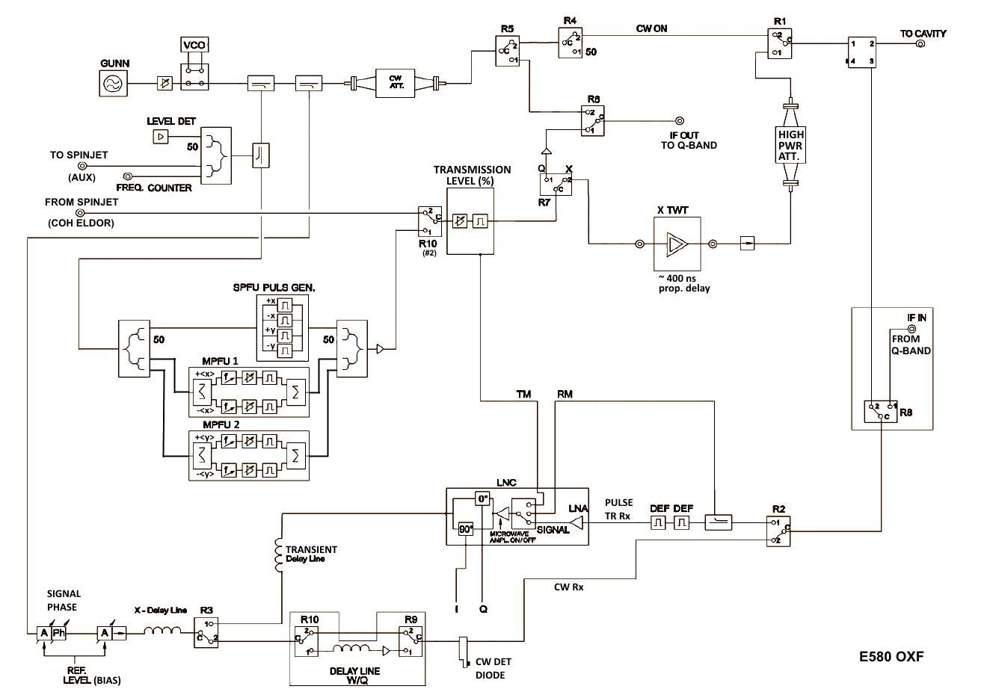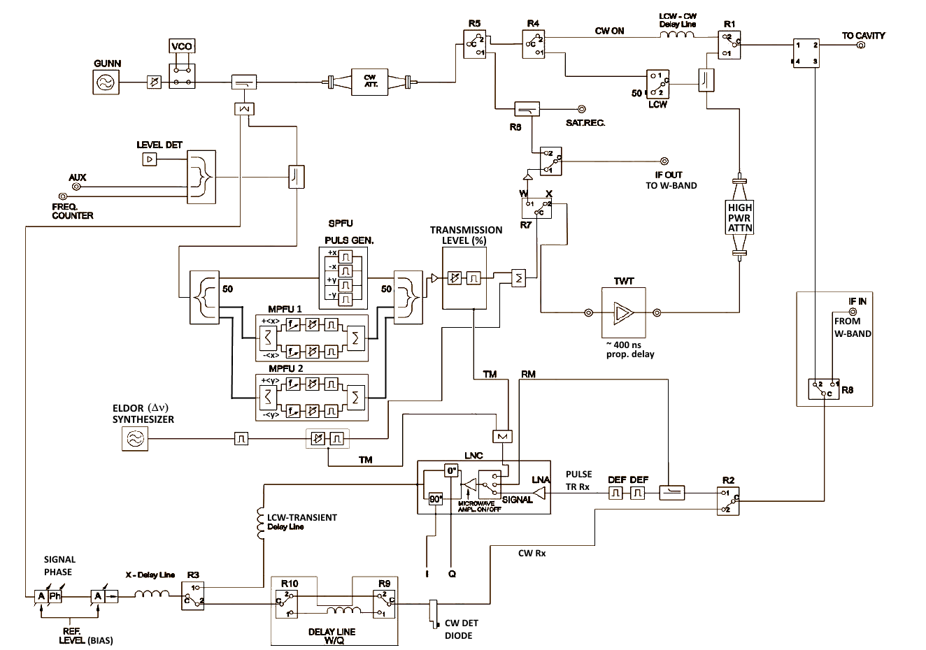

E680 X-band Bridge Schematic

Q-band IF Bridge Schematic, E580 Oxford

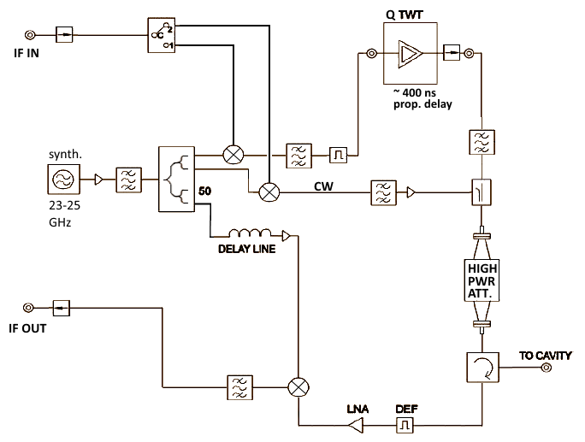

TWT-A, briefly: The electrons traveling through the helix continuously drift toward the decelerating electric field of RF causing an increase in wave amplitude. The electrons will lose kinetic energy and gain potential energy, thereby adding energy to the retarding field. The modulated electron beam close to a slow wave circuit induces an image current, 90 deg. out of phase, acting as capacitive RF load to slow down wave.

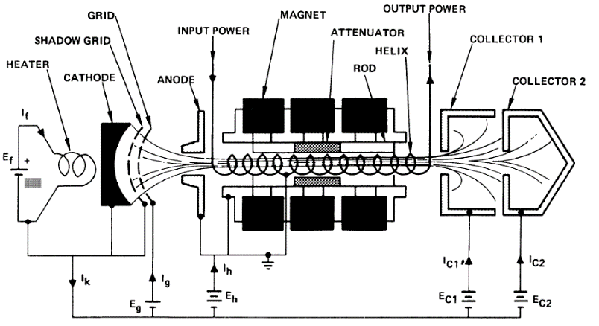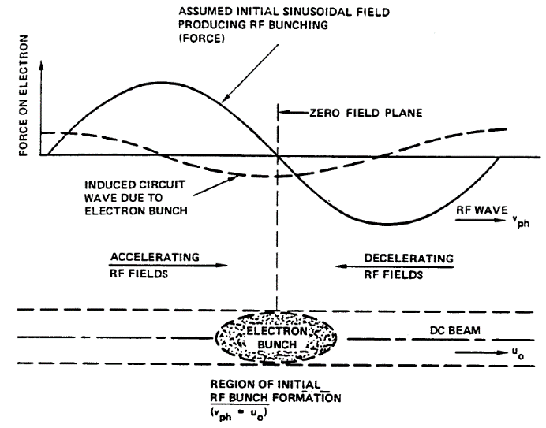

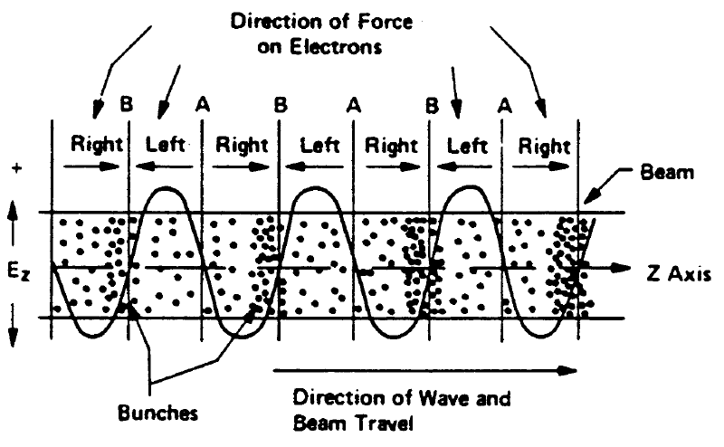 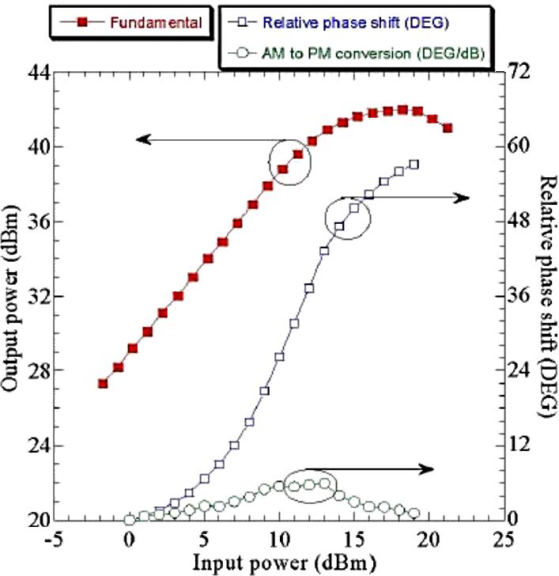

EPR standard: clear fused, -irradiated SiO2

Wilmad cat.# WG-R-E01; 4mm O.D. fused quartz rod

Irradiated by NIST to a dose of 261 Gy with 60Co gamma source. X-band reference standard for pulsed EPR: 100M. E*ꞌ*1 centres are set by heating at 575 K and are annealed by heating the above 700 K.

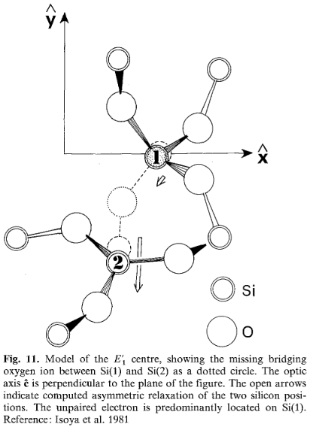EightyMinDoubN

**Figure.** EPR tube exposed to synchrotron beamline

as measured at room temp., above, and 5K, below.

g5k40db16(what’s wrong with this plot?). *A*(29Si) ~ 420 G.

1. CW-EPR detection

(mw power, dB0/dt, mod. Ampl.)

2. Pulsed FID and Echo FT-EPR

3. On-res. vs. Off-res. Echoes

4. Echo-det. Field sweep

(pulse length,.)

5. FID det. Field sweep



Simulations and analysis of crystalline right-hand **-SiO2

Spin Hamiltonian $H_{0}=μ_{Β}{\vec{B}}^{'}⋅g⋅{\hat{S}}_{z}+\sum_{j=1}^{3}{{{\hat{I}}^{'}}_{j}⋅A_{j}⋅\hat{S}}$ $H_{1}=μ_{Β}{{\vec{B}}^{'}}_{1}⋅g⋅{\hat{S}}_{x}$

Electron Zeeman

ge = 2.00231930436

giso = 2.0008

g (geff-ge) principle values; [ -6 -18 -20 ] x10-4; Silsbee 1961

[ -6 -18 -21 ] x10-4; Feigel, Anderson 1970

Hyperfine Interactions { 29Si (4.685% natural abundance), I=1/2, Silsbee 1961}

1 cm-1 = 29,979.2458 MHz, values in 10-4 cm-1

*A*1(1) = 424; *A*2,3(1) = 364; (orientations omitted here…)

*A*1(2) = 8.61; *A*2,3(2) = 6.89;

*A*1(3) = 9.15; *A*2,3(3) = 7.34;

EPR Simulation outline

1. Build Hilbert space spin matrices, separate isotropic and anisotropic terms

2. Make orientational grid in lab frame and determine geometric weights

3. For each sample orientation in magnet find resonance field:

a. Rotate anisotropic G-matrix into new position

b. Solve eigenvalues vs. field, possibly with optimized sparsity

c. Find field positions where transitions (Ei-Ej) = microwave frequency

d. Calculate transition intensity: 

4. Interpolation over orientational grid, f(intensity, field)

5. Construct spectrum with lineshape convolved at each resonance field position

6. Interpolation to desire field range and number of points

7. Convolution to field derivative

simulation input and plotting

clear all; clc; fs = 12; lw = 1.25;

sys.g = [-6 -18 -20]*1e-4 +2.00231930436;

sys.lw = [0.05 0.1];

sys.Nucs = 'Si,Si,Si';

sys.A = [424 364 364;8.61 6.89 6.89; 9.15 7.34 7.34].*1e-4*29979.2458;

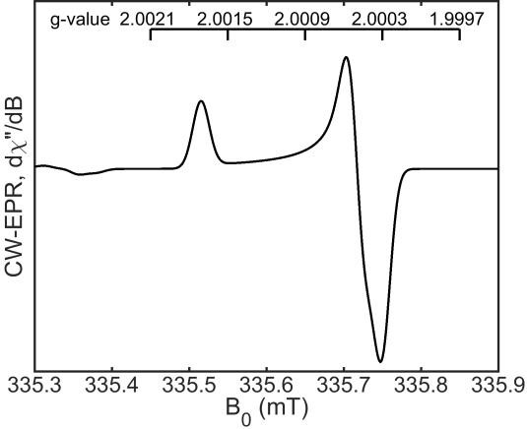sys.lw = [0.025 0];

exp.mwFreq = 9.4;

exp.nPoints = 65536;

exp.Harmonic = 1;

exp.Range = [-1 1]*50+71.447735*exp.mwFreq/mean(sys.g);

opt.nKnots = [64 1];

opt.Method = 'matrix';

[x,y,trans] = pepper(sys,exp,opt);

figure(1); clf;

plot(x,y,'k','LineWidth',lw); hold on;

xtick = (335.45:0.1:335.85);

ylev = [1.15*max(y) 1.25*max(y)];

for ii = 1:numel(xtick)

plot([xtick(ii) xtick(ii)],[ylev(1) ylev(2)],'k','LineWidth',lw-1); hold on;

text(xtick(ii)-0.04,1.35*max(y),num2str(71.447735*exp.mwFreq./xtick(ii),'%1.4f'));

end

plot([xtick(1) xtick(end)],[ylev(2) ylev(2)],'k','LineWidth',lw-1);

text(xtick(1)-0.13,1.35*max(y),'g-value');

pbaspect([1.25 1 1]); axis tight; box on;

xlim([335.3 335.9]); ylim([1.05*min(y) 1.5*max(y)]);

xlabel('B_0 (mT)','FontSize',fs,'FontName','Arial');

ylabel('CW-EPR, d\chi"/dB','FontSize',fs,'FontName','Arial');

title('alpha-SiO2','FontSize',fs,'FontName','Arial');

set(gca,'ytick',[],'LineWidth',lw,'FontSize',fs,'FontName','Arial');

BDPA , 0.5% by weight in polystyrene

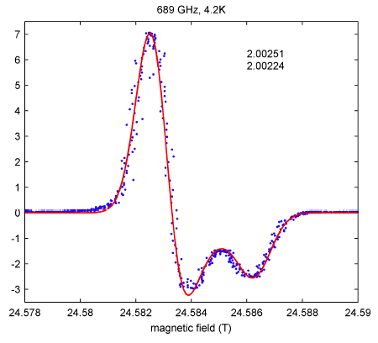

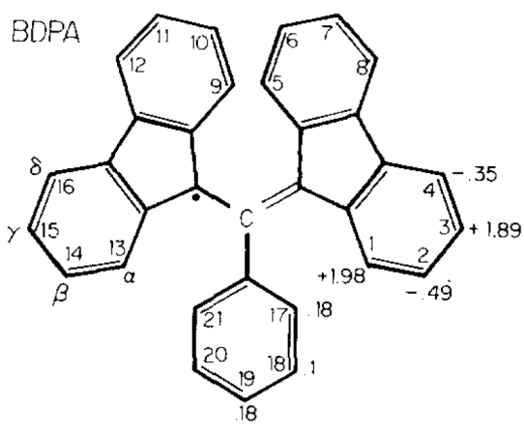

**,**-bisdiphenylene-**-phenylallyl, hyperfine values in Gauss

X-band Bruker Pulse Course 2007

1. CW-EPR to verify signal 3-1 to 3-25 (*E500 basic manual*)
2. Find and optimize echo signal 4-13 to 4-24 5-37 to 5-39
3. Do an echo-detected field sweep 5-40 to 5-43
4. Set field to max of signal
5. Davies-ENDOR 14-1 to 14-8; 14-21 to 14-25

7-1 to 7-10 (*E560 ENDOR manual*)

1. Mims-ENDOR 14-11 to 14-13;

8-11 to 8-18 (*E560 ENDOR manual*)

1. *ELDOR-detected NMR 10-13 to 10-14;*

simulation input and plotting

clear all; clc;

fs = 12; lw = 1.25;

sys.g = [2.00251 2.00251 2.00224]; % Stoll 689 GHz data, isotropic value 2.00242

sys.Nucs = '1H,1H,1H,1H,1H,1H,1H,1H'; %,1H,1H,1H,1H,1H,1H,1H,1H,1H,1H,1H,1H,1H';

sys.A = [1.98;1.98;1.98;1.98;1.89;1.89;1.89;1.89].*2.8025; %;...

%-0.49;-0.49;-0.49;-0.49;-0.35;-0.35;-0.35;-0.35;0.18;0.18;0.18;0.1;0.1].*2.8025;

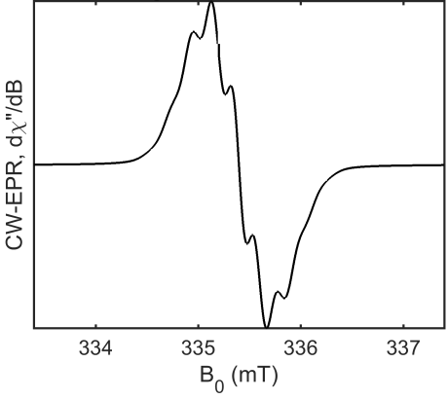sys.lw = [0.20 0.1];

exp.mwFreq = 9.4;

exp.nPoints = 2048;

exp.Range = [-1 1]*2+71.447735*exp.mwFreq/mean(sys.g);

opt.nKnots = [17 1];

opt.Method = 'perturb';

[x,y,trans] = pepper(sys,exp,opt);

plot(x,y,'k','LineWidth',1.25);

pbaspect([1.25 1 1]); axis tight; box on;

xlabel('B_0 (mT)','FontSize',fs,'FontName','Arial');

ylabel('CW-EPR, d\chi"/dB','FontSize',fs,'FontName','Arial');

title('BDPA, g = 2.00254 +/- 0.000032','FontSize',fs,'FontName','Arial');

set(gca,'ytick',[],'LineWidth',lw,'FontSize',fs,'FontName','Arial');

Transient EPR of Zn-TPP at 85 K; per discussion, not demonstration

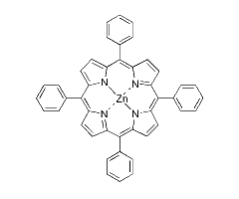 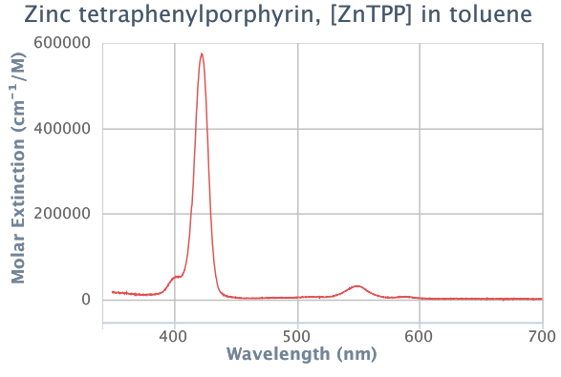

http://omlc.org/spectra/PhotochemCAD/html/100.html

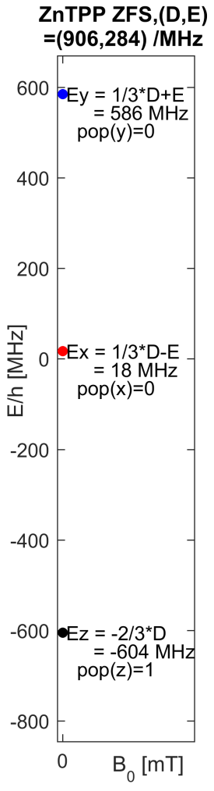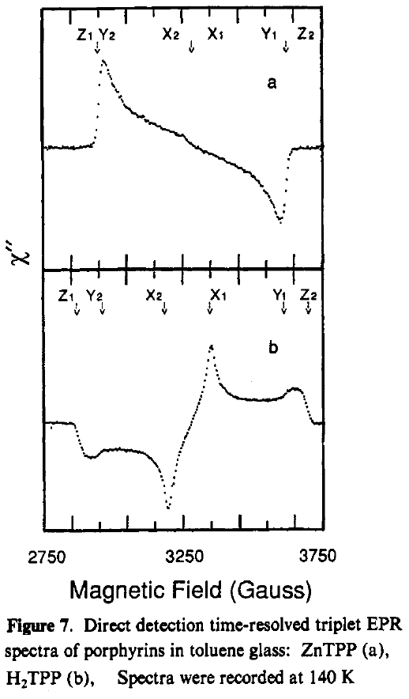A LASER flash of ca. 7 ns length produces an excited singlet state (S=0) that leads to the formation of an excited triplet state (S=1) via inter-system crossing (ISC). Typically, this would be at 355 nm or 532 nm with a Nd:YAG LASER, but with an Optical Parametric Oscillator (OPO) now in CAESR, 410-1700 nm are presently available via fibre coupling to any of the three magnets in F11 & F12. This allows selection of the S0 🡪 S2,Soret band, a.k.a. B-band, at ca. 423 nm and S0 🡪 S1, Q-band, ca. 550 nm.

1) Soret: ϵ423nm = 572.6 cm-1 mM-1

2) Q-band: ϵ550nm = 29.5 cm-1mM-1

The inner diameter of the EPR tube is 2.5 mm, so for photoexcitation at 550 nm and an objective of an Absorbance of 2, the concentration would be ~0.27 mM. Choice of photoexcitation with a lower molar extinction has the advantage of allowing higher sample concentrations. However, higher sample concentrations may lead to aggregation and additional photophysical considerations like triplet-triplet quenching. In porphyrins, the Q-band region is also complicated by photoselective properties of molecular orientation.

Zero-Field Splitting(ZFS) g-value ISC ratio

D/MHz E/MHz gx gy gz Px-Py:Pz-Py Ref. (DOI)

ZnTPP 906 284 2.0020 2.0024 1.9968 0:1 10.1021/jp1023197

Based on Discussion: DEER, with AWG, using PulseSPEL (see NotesOnDEER.txt)

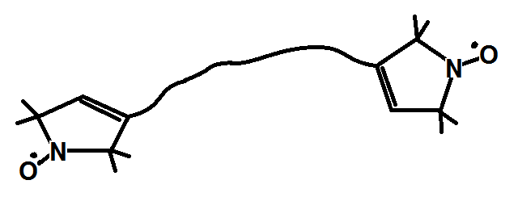Hands-onInstrument Use

Bruker DEER standard, bis-nitroxide, 22 Å apart.

85 Kelvin *Not a Coal sample!*

**Bruker Pulse Course 2007**

1. CW-EPR to verify signal (optional, skip) 3-1 to 3-25 (*E500 basic manual*)
2. Find and optimize echo signal; SRT ~ 200 us 4-13 to 4-24 5-37 to 5-39

Variation of high power attenuator setting, field position

1. Do an echo-detected field sweep 5-40 to 5-43

Centre at g~2.005, sweep width 150 Gauss, 300 points, 100 shots

Acquisition from Tables

1. Set field to max of signal

Check SpecJet with 1 shot. If it clips the window,

then optimize Video Gain and go back to step 2.

1. Inversion recovery with echo detection (T1) 6-1 to 6-23; 8-5 to 8-11

Load program, defs in PulseSPEL (button at bottom of Expt window)

Acquisition from PulseSPEL, compile program & defs in PulseSPEL

1. 2-pulse decay of phase memory time (TM) 6-8 to 6-10; 8-15 to 8-17

x-axis label should be 2 tau.

1. 2-pulse ESEEM 7-1 to 7-9; 9-1 to 9-9

x-axis label should be tau.

1. 3-pulse ESEEM 7-9 to 7-11; 9-14 to 9-28

x-axis label should be tau + T.

**Background Straight**

**Reading Procedure**

***See print-out***